AI ASSISTANT CODING
ASSIGNMENT-4
Name: Thrishala Jakkaraju
Hallticket:2303A51514
Batch:22
Task Description-1
• Zero-shot: Prompt AI with only the instruction. Write a Python function to determine
whether a given number is prime
Expected Output-1
• A basic Python function to check if a number is prime, demonstrating correct logical
conditions without relying on examples or additional context.
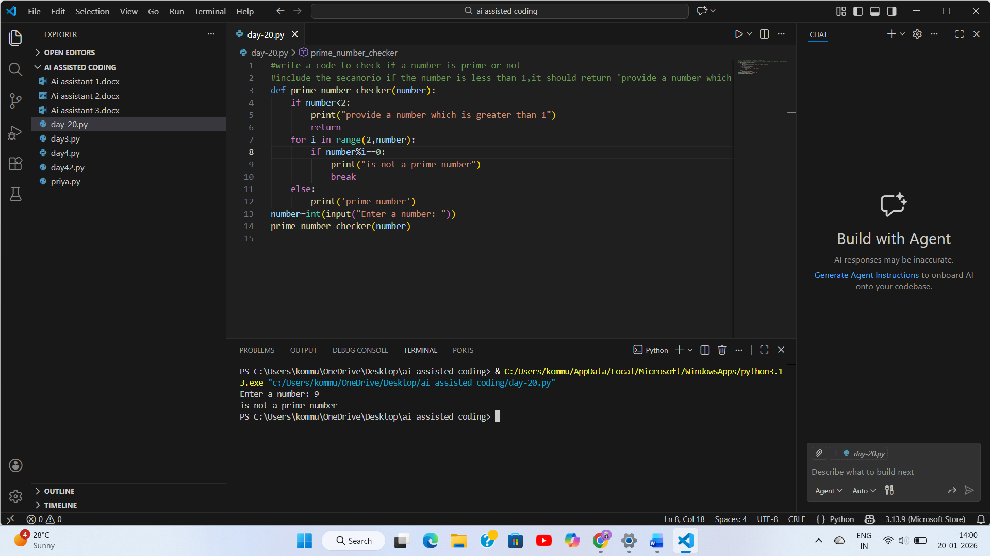
Explanation:
In this program, we check whether a given number is a prime number or not. First, we check if the number is less than or equal to 1. If it is, then it is not a prime number. After that, we use a loop to divide the number by all values starting from 2 up to one less than the number. If the number is divisible by any of these values, it means the number has more than two factors, so it is not prime. If the loop finishes without finding any divisor, then the number is a prime number.

Task Description-2
• One-shot: Provide one example: Input: [1, 2, 3, 4], Output: 10 to help AI generate a
function that calculates the sum of elements in a list.
Expected Output-2
• A correct conversion function guided by the single example.
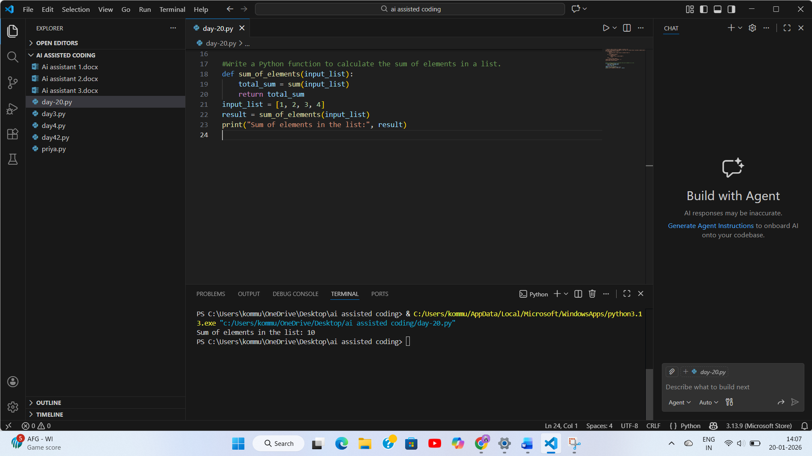
Explanation:
In this program, we calculate the sum of all elements in a list. The given example shows that all the numbers in the list should be added together to get the final result. First, we initialize a variable total with 0. Then, we use a loop to go through each number in the list and add it to total. After the loop ends, the function returns the total sum of the list elements.
Task Description-3
• Few-shot: Give 2–3 examples to create a function that extracts digits from an
alphanumeric string.
Expected Output-3
• Accurate function that returns only the digits from alphanumeric string.
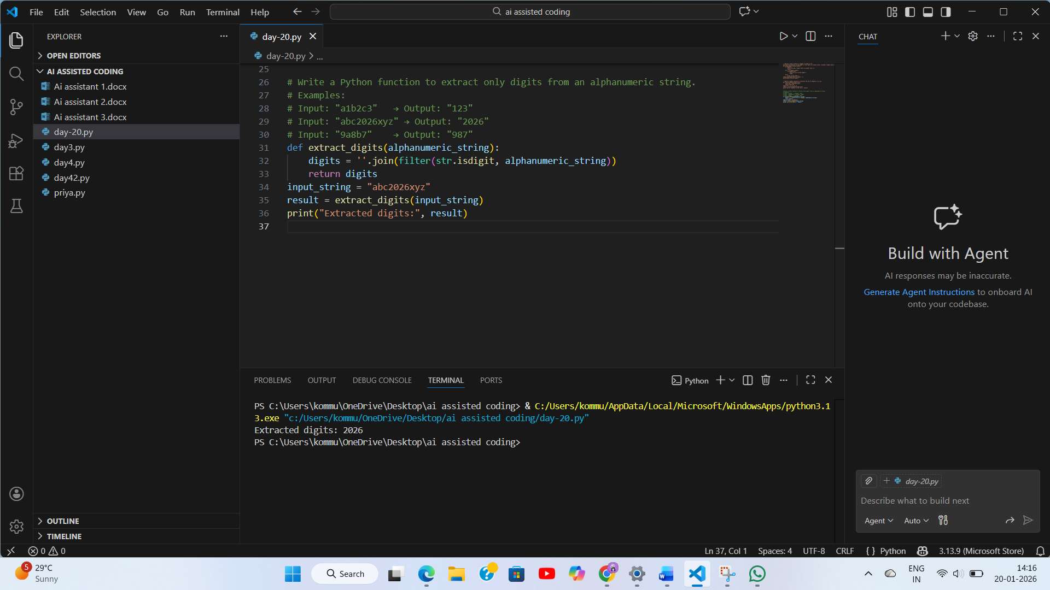
Explanation:
This program is used to extract only the digits from an alphanumeric string. First, an empty string named digits is created to store the numbers found in the input string. Then, a loop checks each character in the string one by one. If the character is a digit, it is added to the digits string using isdigit(). Characters that are not digits are ignored. After checking all the characters, the function returns a string that contains only the digits in the same order as they appear in the original string.
Task Description-4
• Compare zero-shot vs few-shot prompting for generating a function that counts the
number of vowels in a string.
Expected Output-4
• Output comparison + student explanation on how examples helped the model.

ZERO SHOT
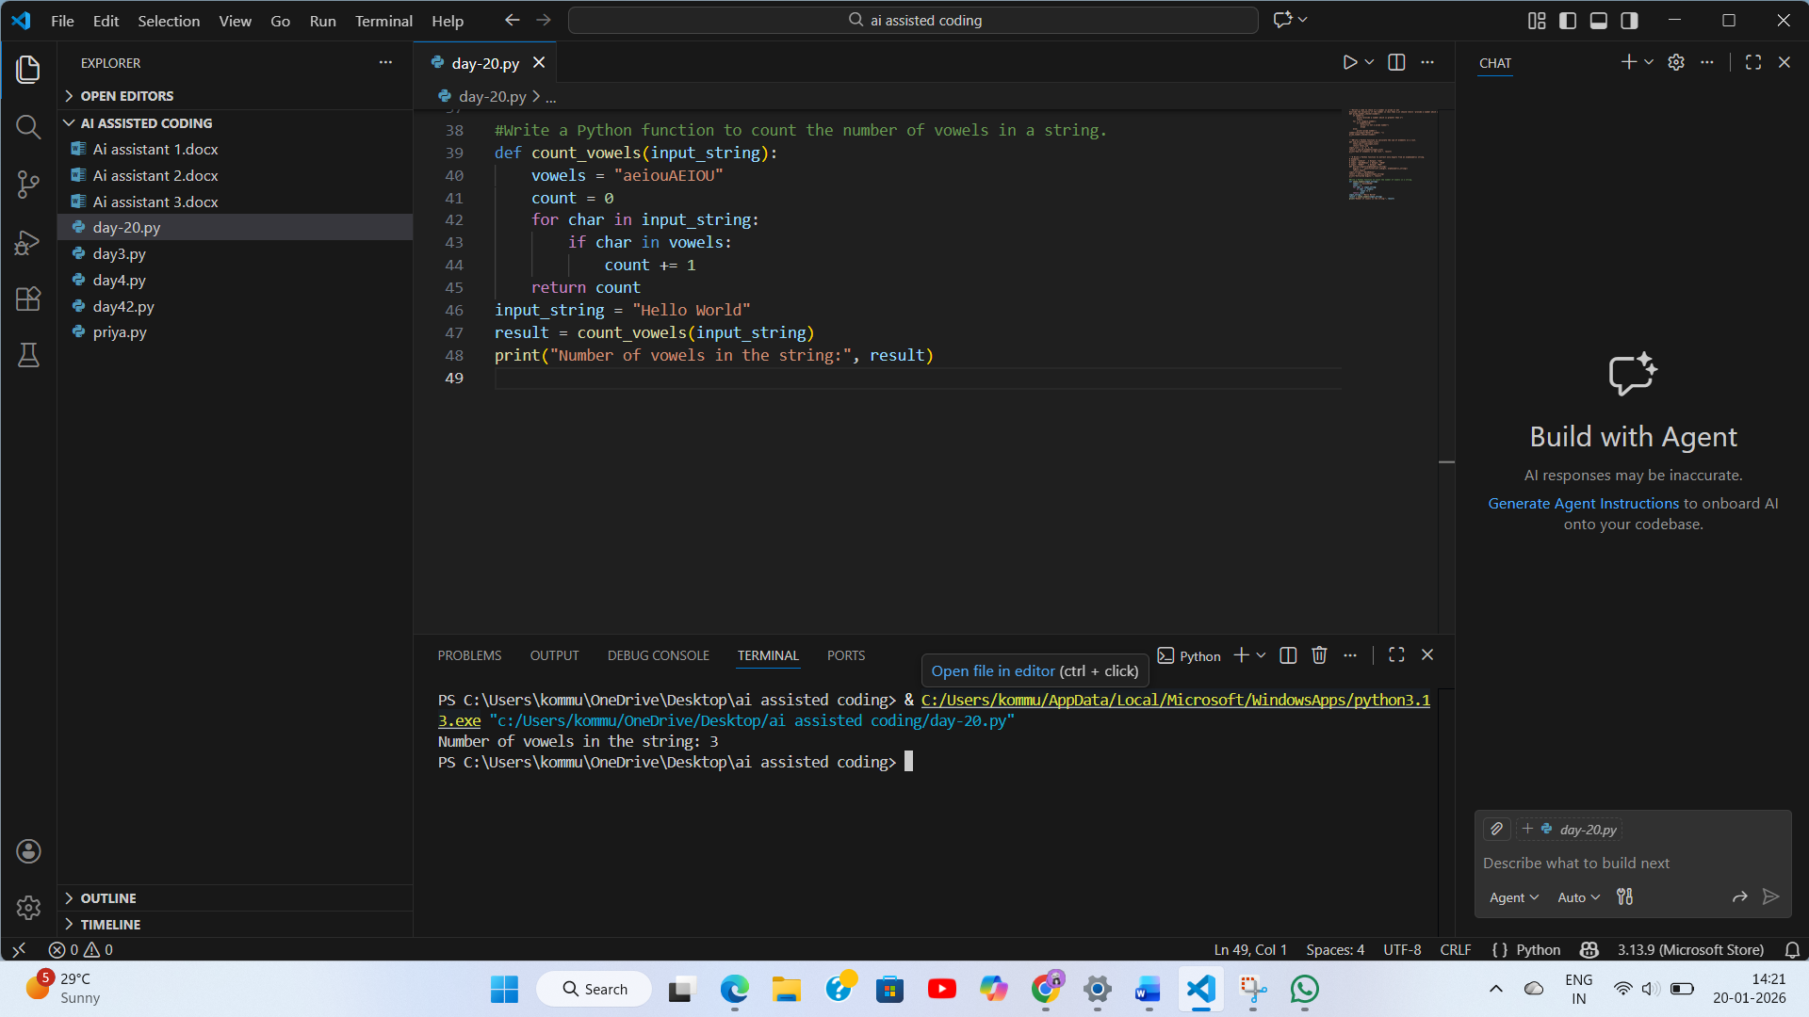
FEW SHOT:
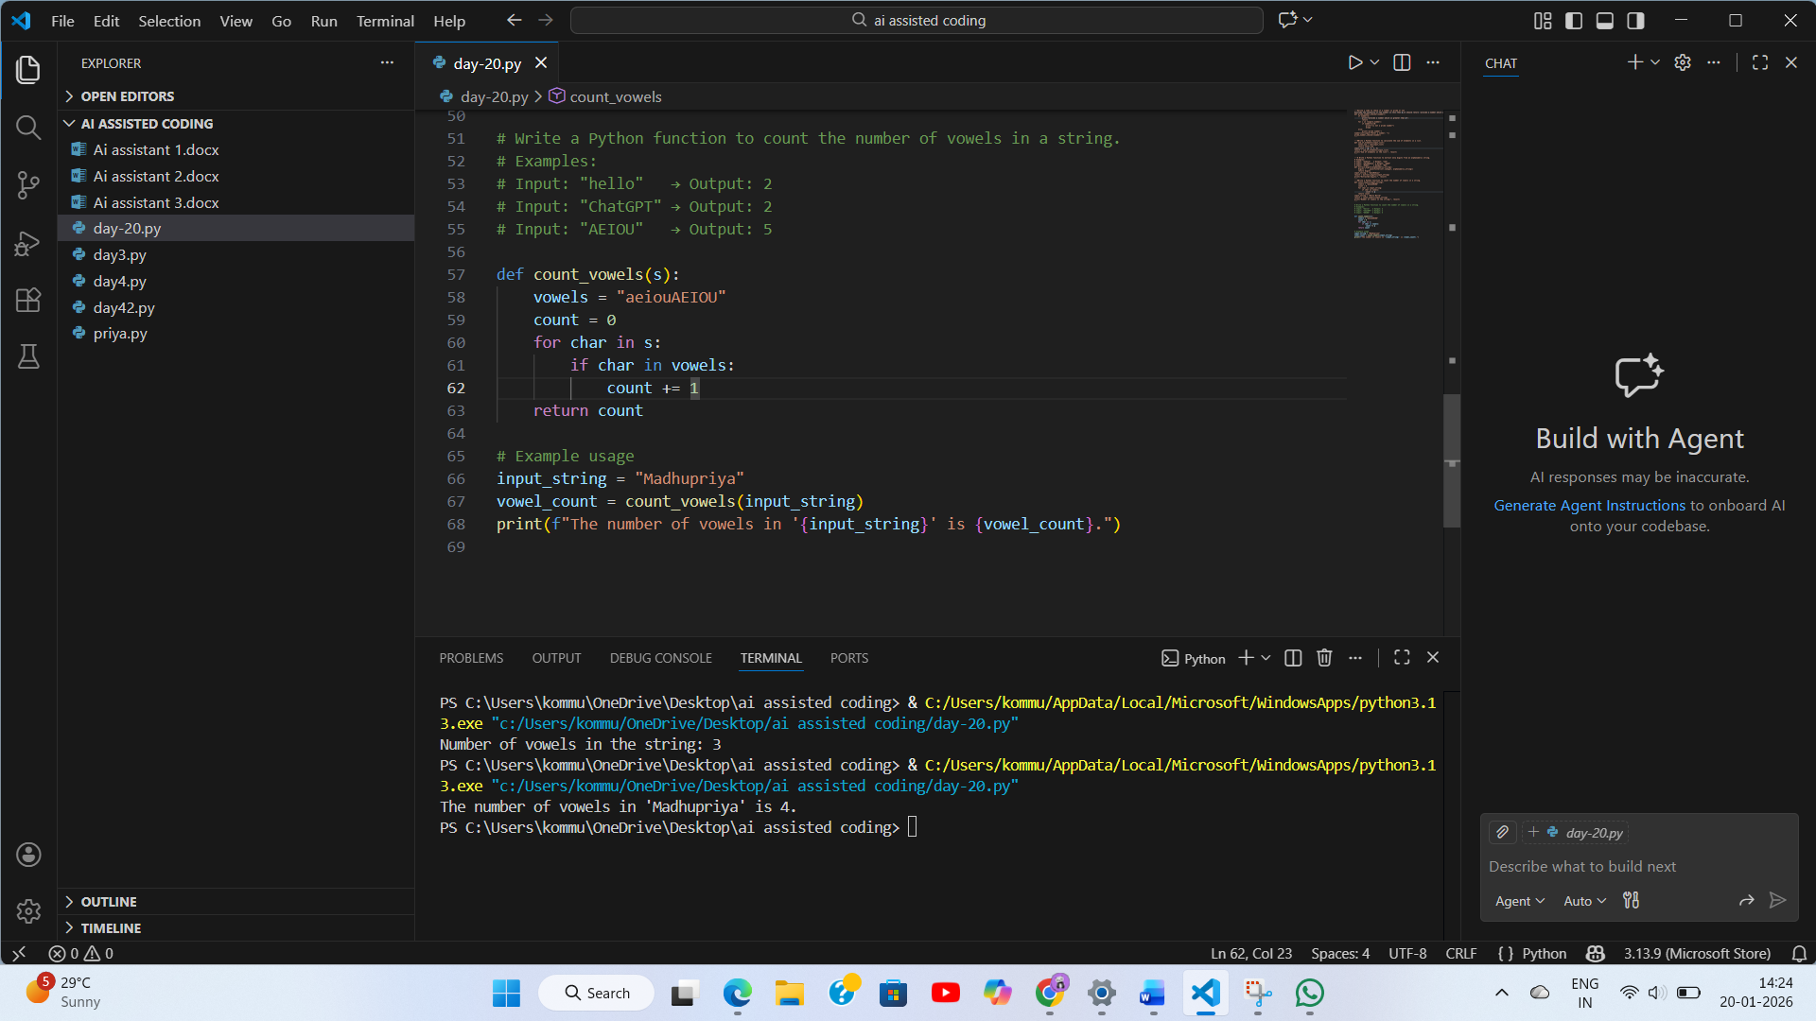
Explanation:
In zero-shot prompting, the AI receives only the instruction, so it generates a basic solution using a simple loop to count vowels. The logic is correct but straightforward. In few-shot prompting, the given examples help the AI understand different cases, such as strings with many vowels and strings with no vowels at all. Because of these examples, the AI produces a more concise and efficient solution. This shows that providing examples improves the quality, clarity, and confidence of the generated code.
Task Description-5
• Use few-shot prompting with 3 sample inputs to generate a function that determines
the minimum of three numbers without using the built-in min() function.
Expected Output-5
• A function that handles all cases with correct logic based on example patterns.
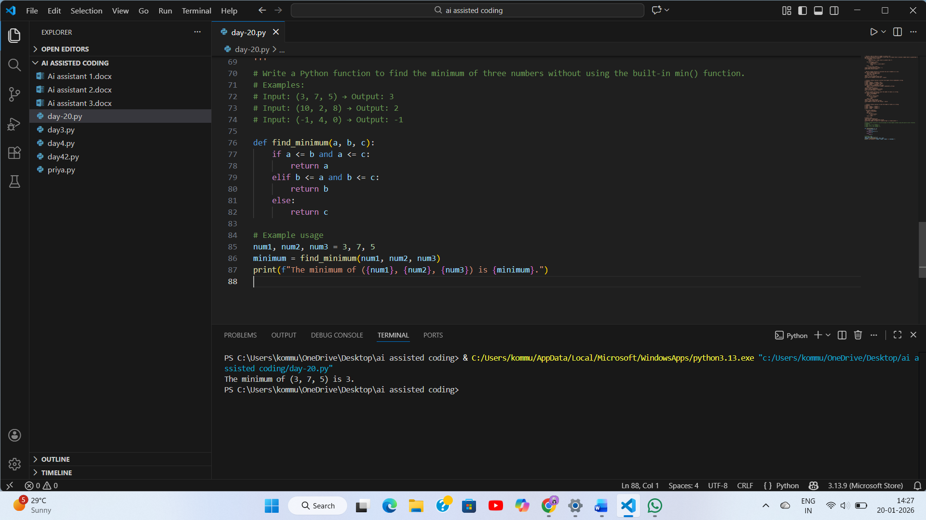
Explanation:
In this program, we find the smallest number among three given numbers without using the min() function. The examples show that the function should correctly handle different values, including equal numbers. First, the function compares the first number with the other two. If it is smaller than or equal to both, it is returned as the minimum. If not, the second number is compared with the other two. If it is the smallest, it is returned. Otherwise, the third number is returned. This logic ensures that all possible cases are handled correctly.

